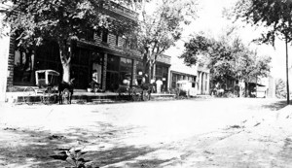
As early as 1817 there were settlers along Lick Creek in the southwest part of the area later named in 1820 Ralls County Missouri. Other sources show that there may have been earlier settlement in the area, but no official documentation has been found yet only family histories and stories. In the 1800s and early 1810s settlers began moving into Salt River and its tributaries like Lick, Spencer and other creeks that made up its drainage. Various tribes of Indians became alarmed and attacked some of these early settlers, killing many and the troops sent to protect them. No such activities can be found to have taken place on Lick Creek, but one may have taken place on Spencer Creek just to the east a few miles.
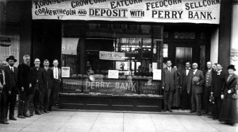
The Salt River valley became known as the “Bloody Saline” and the few settlers that had settled in the area moved to safer locations, some never to return. A few years after the War of 1812, which caused many of the problem tribes to leave the area, the Salt River valley began to be settled again. At about this time the first settlers came to the Lick Creek. Most of the first official settlers were from counties of Bath and Montgomery in Kentucky. They were English stock and had mostly settled first in Virginia before going to Kentucky. As the area developed families came from many other states and origins. Some of the early families that settled alone Lick Creek were: Abby, Barnards, Biggers, Bradshaw, Cartmill, Carter, Clark, Coil, Crockett, Crosthwaite, Ellis, Ely, Fagan, Gallaher, Gill, Hall, Hurley, McElroy, Mace, Martin, Mayhall, Menefee, Moore, Muldrow, Myers, Phillips, Purvis, Quinn, Rice, Salling, Scobee, Underwood, Wasson, Wolfe and Many others.

Old Perry Bank in Downtown Perry, MO.
Some of these family names can still be found in the Perry area yet, but many are gone or disappearing. 1912 Perry, Missouri Corn Carnival on Main Street. In the 1830s or early 1840s Henry C. Wolfe built a large log cabin just north of present Perry. He added rooms, in the later rooms he operated a small store and in1846 a post office called Lick Creek. This post office remained active till May 1866 when it was replaced by the Perry post office. A David Bradshaw is believed to have built a one room log cabin in 1819 in the west side of present Perry and was likely the first building in the limits of the present town. All early maps show the area what became Perry as a crossroad of early unnamed roads. Men who had a vision for future used the traffic at this location to begin a business. Thomas Jefferson “Jeff” Ellis as early as 1854 had a store that sold goods in the area that later became the town of Perry. Thomas Jefferson “Jeff” later founded Center MO. Perry Crosthwaite and Andersonville Mayhall operated a three-story mill on Lick Creek on the west side of town. In 1864 Thomas F. Gill opened a store on the southeast corner of Palmyra and Main streets. About a year after the end of the Civil War in 1865 and 1866 Perry Crosthwaite and Andersonville Mayhall bought land from a Dr. Peter A. Salling the land that began the town of Perry.

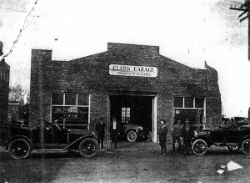
Clark Garage on Palmyra Street in Perry, MO.
In July 1866 the town was plated and named for Mr. Crosthwaite. Thomas F. Gill alone owned, sold or operated hotels, dry goods, grocery, drug stores, hardware, lumber, mills, livery stables, wagon and blacksmith shop, an opera house, more than one farm in Perry at one time or the other. He also established the Perry Bank and he was a key man in getting the “Short Line Road” into Perry. It is being estimated that he built and at one time half the residence and business properties in Perry. Without him Perry may not have become the town that it did. The 1823 “A New America Atlas” by Henry S. Tanner showed coal in the area which later became Perry. By 1892 three mines operated in the area producing more than 600 tons a year. A report of railroad shipments for the year 1901 showed 920 cars of coal shipped from Perry by the Short Line Railroad.
The strip and underground mining peaked in the 1920s and 1930s with operation continuing into the 1950′s. Mining began again in 1980 and operated for a short time. In 1892 the Perry branch of the St. Louis and Hannibal “Short Line” Railroad was completed to Perry. The railroad was a “shot in the arm” for Perry and was a factor in the fast growth in the late part of the nineteenth and first part the twenty centuries. Trucks and wars slowly caused the end of the Perry branch of the railroad in the early 1940s. The metal was used of the World War II cause. There were large orchards of apples in the Perry in the first part of the twentieth century. A newspaper article in 1915 shows that J. R. Fletcher had 100 acres of apples on the old William Woods place. Others reported were: Marion Richards 75 acres, Dr. Bledsoe 25 acres, S. C. Gill 45 acres, W. R. Netherland 35 acres, G. C. Cole 15 acres, John Hanger 40 acres, Mrs. Lou Smith 10 acres, Elliott Brothers 20 acres and many small orchards. Another article said that Marion Richards had 7,000 trees. R. S. Buchanan Co. operated a poultry plant in Perry and Center till his retirement in 1940. The product was shipped to eastern markets by train and refrigerated trucks. The Sthele family in the early part of the century manufactured a combination cooker and heater stove in Perry. Other products which have been manufactured in Perry were cigars, bricks, milk bottle carriers, hog catchers, soda, and water. For more information about Perry or Ralls County, stop by the Ralls County Historical Society Museum and Library at 120 East Main Street in downtown Perry. Hours are Friday and Saturday 9 to 5, Sunday 11 to 4 and Wednesday 10 to 5. More information can also be obtained on their website.

